# **Scripting Task**

1. Create a shell script to print the HTTP error code of guvi.in & print, the success/failure message based on the error code response

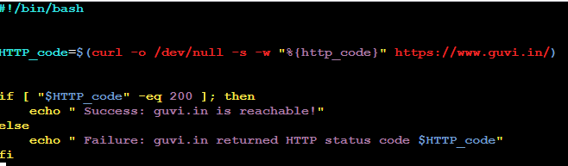

I created a file check_guvi.sh , where “if [ "$HTTP_code" -eq 200 ]; then”

Output is:



And “if [ "$HTTP_code" -eq 301 ]; then”

Output is:



1. Given a file, replace all occurrences of the word "give" with "learning" from the 5th line till the end in only those lines that contain the word "welcome"

